CURRICULUM VITAE
of
MD. JAFAR ALI

MD. JAFAR ALI
RESUME OF
Mobile No. +8801725-899584 / 01709900004

Objectives

Seeking position in a reputed organization where hard work, sincerity, creativity, development & motivation are the keys towards success.

Personal Profile

Name : MD. JAFAR ALI
Father’s name : Md. Ibrahim Ali
Mother’s name : Jarina Begam
Mailing Adress : Vill : Najorpur,
P.O : Pirgonj,
P.S : Natore,
Dist : Natore.
Cell No- 01725-899584

Permanent Adress : Vill : Najorpur,
P.O : Pirgonj,
P.S : Natore,
Dist : Natore.
Cell No- 01725-899584

Date of birth : 08 February, 1995.
Religion : Islam
Nationality : Bangladeshi by birth
Sex : Male
Marital status : Single
Blood Group : (O +) Positive

Academic Profile

Name of Exam | Group/ Subject | Name of Institution | Year | Division/  Grade | Board/  University
S S C | Tecnical | Pirgonj High School | 2010 | 4.18 | Dhaka
Diploma-in-Fisheries | Fisheries | Tamaltala Agr. & tecnical College | 2014 | 3.75 | Dhaka

Computer Skill

- Good skill in Microsoft Word, Microsoft Excel, Power-point & Adobe Photoshop 7.0.
- Reasonable typing speed of English & skilled in Internet browsing.

Capabilities

- Leadership skill & working capability in group & individual working condition.
- goal oriented hard working ability, like to take & meet challange.
- Have sound presentation skill, Work out & presented many cases.
- Cooperate with all the depertments with helpful & fact fully way.
- Well relation with the customer.
- To ensure the standard quality to customer.
- Ready to work any where in Bangladesh.

Specialties

- Informative & immensely observent.
- Communicative & friendly.
- Enthusiastic, self motivate, industries & punctual.
- Ability manages things & work with group.
- Adoptive to new tecnology & a quick learner.

Experience

Company Name : Lava International Bangladesh Ltd.
Designation : Territory Sales Officer
Duration : 01/01/2015 to till now.
Location : Natore

Interest

- Reading Book.
- Travelling.
- Listening Music
- Internet Browsing

Certificate and Consent

I Undersinged and certify that, to the best of knowledge and belief , this CV correctly describes my qualification, my experiences and myself. I understand that any willful misstatement described hereby may lead to my disqualification or dismissal.

Reference:

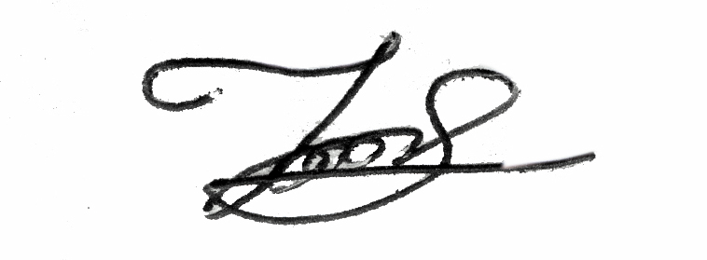

......................................
(MD. JAFAR ALI)

